# Solution

The feature: Hiding Sections is not intended to perform the functionality that was explained by the user in his topic definition. In order to hide sections for some users based on a specific field value or restriction set. The user should go to the Module: Restrict Access > Restrict Access Settings and use the feature: Restricting Activity Access:

## Feature: Restricting activity access

In the settings of each activity there is a Restrict Access section. To get to this, click 'Edit' alongside the activity you want to restrict and then choose 'Edit Settings', or add a new activity, which will bring you to the settings page.

In the 'Restrict Access' section of the activity settings page, click the 'Add restriction' button. A choice of conditions appears:

[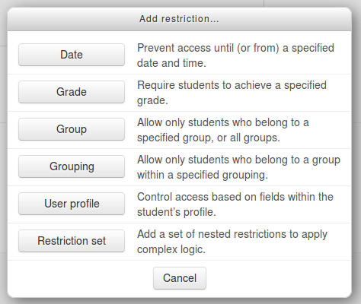](https://docs.moodle.org/31/en/File:add_restriction_popup.png)

Restriction can be based upon [Activity completion](https://docs.moodle.org/31/en/Activity_completion), date, grade, the group or grouping the students are in or even user profile fields. The 'Restriction set' button also allows for more complex criteria requiring nested conditions.